EXP-6 Analog Beamforming

AIM: To analyze how the 3-dB beamwidth of a Uniform Linear Array (ULA) varies with the number of antenna elements in an analog beamforming system using MATLAB.

APPARATUS REQUIRED
1.MATLAB / Octave software (with Signal Processing and Plotting tools)
2.Computer or Laptop with minimum 4 GB RAM
3.Simulation script for Array Factor analysis
4.Graph plotting utilities (built into MATLAB)
5.Documentation tools (MS Word for tabulation of results and screenshots

Theory
Analog beamforming controls the direction of signal radiation by adjusting the phase of each antenna element in an array.
For a Uniform Linear Array (ULA) with spacing $d=\frac{λ}{2}$, the Array Factor (AF) is:
$$AF(θ)=\sum_{n=0}^{N-1}{}e^{j2π\frac{d}{λ}n(sin⁡θ-sin⁡θ_{0})}$$
Where:
- $N$= number of antennas
- $θ_{0}$= beam steering angle (broadside = 0°)
- $θ$= scan angle
The 3-dB beamwidth is the angle range where the array factor drops to:
$$AF_{3dB}=\frac{AF_{max}}{\sqrt{2}}$$​AFmax​​
Procedure
- Define wavelength $λ$, antenna spacing $d=λ/2$, and angle range.
- Choose different array sizes $N=8,16,32,64$.
- For each $N$:
  - Compute the Array Factor using summation of phase-shifted elements.
  - Normalize the AF.
  - Extract the −3 dB points by checking AF ≥ AFmax/√2.
  - Compute the 3-dB beamwidth.
- Display beamwidth values for each array size.
- Plot beamwidth vs number of antennas.
CODE:
clc; clear; close all;

%% Parameters
lambda = 1; % Wavelength
d = lambda/2; % Antenna spacing
theta = -90:0.1:90; % Angle scan range (degrees)
theta_rad = deg2rad(theta);

% Array sizes to analyze
N_array = [8 16 32 64];
beamwidth = zeros(1, length(N_array));

for idx = 1:length(N_array)
N = N_array(idx);

% Steering direction (broadside)
theta0 = 0;
theta0_rad = deg2rad(theta0);

% Array Factor Calculation
AF = zeros(size(theta_rad));
for n = 0:N-1
AF = AF + exp(1j * 2*pi*(d/lambda)*n*(sin(theta_rad) - sin(theta0_rad)));
end

% Normalize
AF_norm = abs(AF) / max(abs(AF));

% ---- Compute 3-dB Beamwidth ----
mainlobe_max = max(AF_norm);
idx_3dB = find(AF_norm >= (mainlobe_max/sqrt(2))); % −3dB points
beamwidth(idx) = theta(idx_3dB(end)) - theta(idx_3dB(1));
end

%% Display Results
disp('=== Beamwidth Results (3-dB) ===')
for i = 1:length(N_array)
fprintf('N = %d : Beamwidth = %.2f degrees\n', N_array(i), beamwidth(i));
end

%% Plot Beamwidth vs Antenna Size
figure;
plot(N_array, beamwidth, '-o', 'LineWidth', 2);
grid on;
xlabel('Number of Antennas (N)');
ylabel('3-dB Beamwidth (degrees)');
title('Beamwidth vs Array Size for ULA');
OUTPUTS:
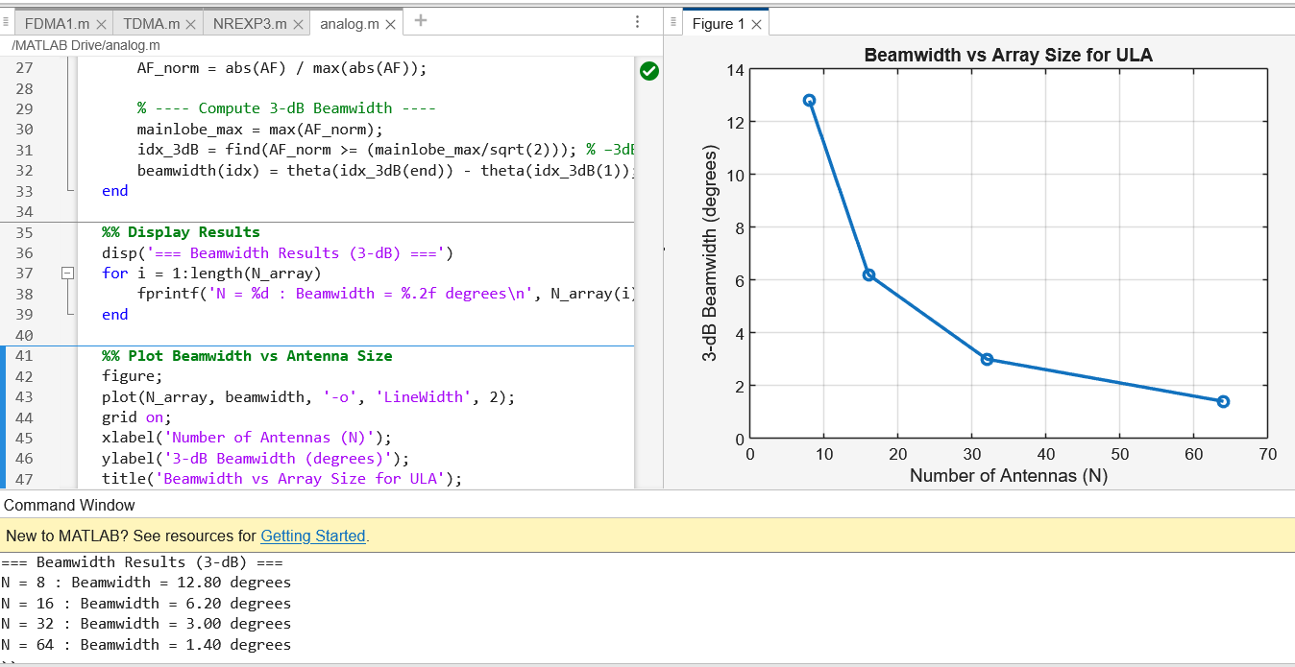

RESULTS:
The simulation shows that the 3-dB beamwidth decreases as the number of antenna elements increases. Smaller arrays (like 8 elements) produce wider beams, while larger arrays (like 64 elements) generate much narrower and more focused beams. This confirms that beamwidth is inversely related to array size in analog beamforming.

